**Option 1: Configure DNS Using Azure DNS**

1. **Create a DNS Zone**:
   * Go to the Azure Portal and search for **DNS Zones**.
   * Click **Create**.
   * Fill in the required details:
     + **Subscription**: Select your subscription.
     + **Resource Group**: Choose the existing resource group or create a new one.
     + **Name**: Enter your DNS zone name (e.g., example.com).
     + **Resource Group**: Specify the appropriate resource group.
   * Click **Review + Create**.
2. **Create A Records for the VMs**:
   * After creating the DNS zone, navigate to it in the Azure Portal.
   * Click on **+ Record set** to create a new record.
     + **Name**: Enter vm1 (this will create vm1.example.com).
     + **Type**: Select **A**.
     + **TTL**: Set your desired TTL (Time to Live), e.g., 3600.
     + **IP address**: Enter the public IP address of VM1.
   * Click **OK** to create the record.
   * Repeat the steps to create another record for VM2:
     + **Name**: Enter vm2.
     + **IP address**: Enter the public IP address of VM2.
3. **Verify DNS Configuration**:
   * You can use the command line or tools like nslookup or dig to check if the DNS records are resolving correctly:

**Option 2: Configure DNS Using an External DNS Provider**

1. **Get Your Public IPs**:
   * Note down the public IP addresses for both VM1 and VM2 from the Azure Portal.
2. **Log into Your DNS Provider**:
   * Access the management console of your DNS provider (like GoDaddy, Namecheap, Cloudflare, etc.).
3. **Create A Records**:
   * Find the section to manage DNS settings or DNS records.
   * Create two A records:
     + For VM1:
       - **Host**: vm1
       - **Type**: A
       - **Value**: Enter the public IP address of VM1.
       - **TTL**: Set your desired TTL.
     + For VM2:
       - **Host**: vm2
       - **Type**: A
       - **Value**: Enter the public IP address of VM2.
       - **TTL**: Set your desired TTL.
4. **Save the Changes**:
   * Ensure that you save or apply the changes.
5. **Verify DNS Configuration**:
   * Similar to the Azure DNS method, use tools like nslookup or dig to verify the DNS records:

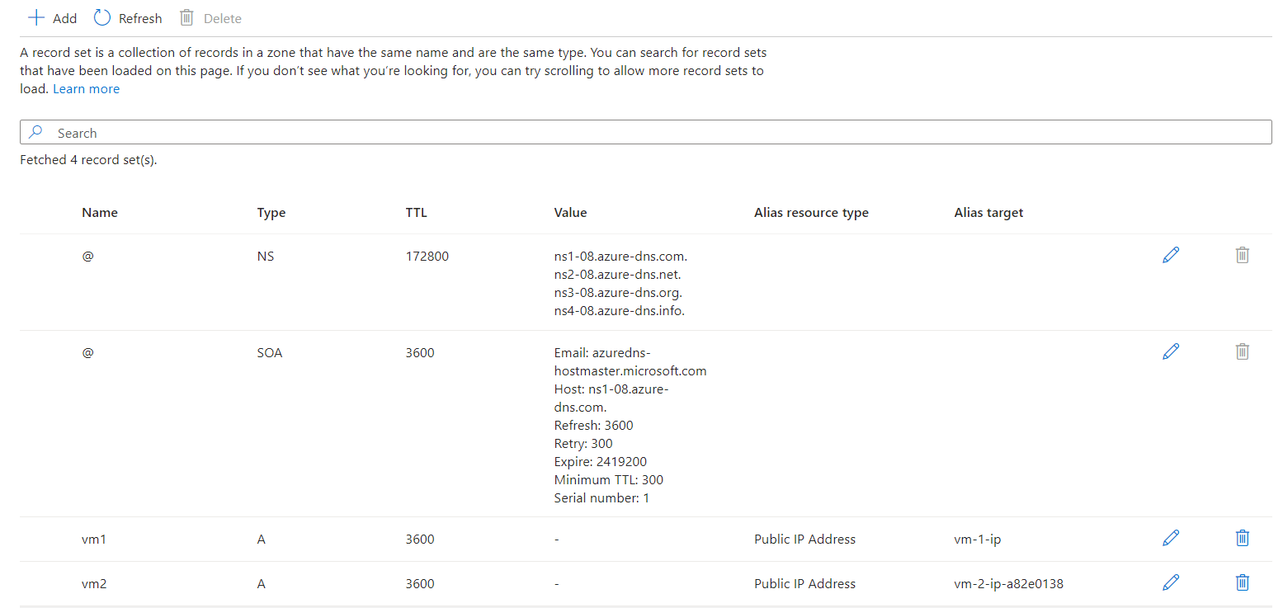

**Conclusion**

With either method, you can now access your VMs using user-friendly DNS names:

* VM1: http://vm1.example.com
* VM2: http://vm2.example.com